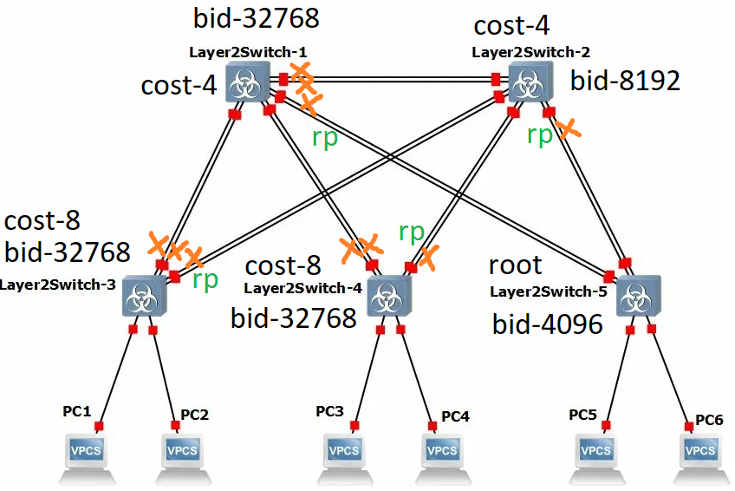

1

VLAN0001

Spanning tree enabled protocol ieee

Root ID Priority 4097

Address 0c8f.16e7.0000

Cost 4

Port 7 (GigabitEthernet1/2)

Hello Time 2 sec Max Age 20 sec Forward Delay 15 sec

Bridge ID Priority 32769 (priority 32768 sys-id-ext 1)

Address 0c9c.51c6.0000

Hello Time 2 sec Max Age 20 sec Forward Delay 15 sec

Aging Time 300 sec

Interface Role Sts Cost Prio.Nbr Type

------------------- ---- --- --------- -------- --------------------------------

Gi0/0 Altn BLK 4 128.1 Shr

Gi0/1 Altn BLK 4 128.2 Shr

Gi0/2 Desg FWD 4 128.3 Shr

Gi0/3 Desg FWD 4 128.4 Shr

Gi1/0 Desg FWD 4 128.5 Shr

Gi1/1 Desg FWD 4 128.6 Shr

Gi1/2 Root FWD 4 128.7 Shr

Gi1/3 Altn BLK 4 128.8 Shr

Gi2/0 Desg FWD 4 128.9 Shr

2

VLAN0001

Spanning tree enabled protocol ieee

Root ID Priority 4097

Address 0c8f.16e7.0000

Cost 4

Port 7 (GigabitEthernet1/2)

Hello Time 2 sec Max Age 20 sec Forward Delay 15 sec

Bridge ID Priority 8193 (priority 8192 sys-id-ext 1)

Address 0ce6.2f9b.0000

Hello Time 2 sec Max Age 20 sec Forward Delay 15 sec

Aging Time 300 sec

Interface Role Sts Cost Prio.Nbr Type

------------------- ---- --- --------- -------- --------------------------------

Gi0/0 Desg FWD 4 128.1 Shr

Gi0/1 Desg FWD 4 128.2 Shr

Gi0/2 Desg FWD 4 128.3 Shr

Gi0/3 Desg FWD 4 128.4 Shr

Gi1/0 Desg FWD 4 128.5 Shr

Gi1/1 Desg FWD 4 128.6 Shr

Gi1/2 Root FWD 4 128.7 Shr

Gi1/3 Altn BLK 4 128.8 Shr

3

VLAN0001

Spanning tree enabled protocol ieee

Root ID Priority 4097

Address 0c8f.16e7.0000

Cost 8

Port 3 (GigabitEthernet0/2)

Hello Time 2 sec Max Age 20 sec Forward Delay 15 sec

Bridge ID Priority 32769 (priority 32768 sys-id-ext 1)

Address 0cb7.77a5.0000

Hello Time 2 sec Max Age 20 sec Forward Delay 15 sec

Aging Time 300 sec

Interface Role Sts Cost Prio.Nbr Type

------------------- ---- --- --------- -------- --------------------------------

Gi0/0 Altn BLK 4 128.1 Shr

Gi0/1 Altn BLK 4 128.2 Shr

Gi0/2 Root FWD 4 128.3 Shr

Gi0/3 Altn BLK 4 128.4 Shr

Gi1/0 Desg FWD 4 128.5 Shr

Gi1/1 Desg FWD 4 128.6 Shr

4

VLAN0001

Spanning tree enabled protocol ieee

Root ID Priority 4097

Address 0c8f.16e7.0000

Cost 8

Port 3 (GigabitEthernet0/2)

Hello Time 2 sec Max Age 20 sec Forward Delay 15 sec

Bridge ID Priority 32769 (priority 32768 sys-id-ext 1)

Address 0c19.6dad.0000

Hello Time 2 sec Max Age 20 sec Forward Delay 15 sec

Aging Time 300 sec

Interface Role Sts Cost Prio.Nbr Type

------------------- ---- --- --------- -------- --------------------------------

Gi0/0 Altn BLK 4 128.1 Shr

Gi0/1 Altn BLK 4 128.2 Shr

Gi0/2 Root FWD 4 128.3 Shr

Gi0/3 Altn BLK 4 128.4 Shr

Gi1/0 Desg FWD 4 128.5 Shr

Gi1/1 Desg FWD 4 128.6 Shr

5

vIOS-L2-01>show spanning-tree

VLAN0001

Spanning tree enabled protocol ieee

Root ID Priority 4097

Address 0c8f.16e7.0000

This bridge is the root

Hello Time 2 sec Max Age 20 sec Forward Delay 15 sec

Bridge ID Priority 4097 (priority 4096 sys-id-ext 1)

Address 0c8f.16e7.0000

Hello Time 2 sec Max Age 20 sec Forward Delay 15 sec

Aging Time 300 sec

Interface Role Sts Cost Prio.Nbr Type

------------------- ---- --- --------- -------- --------------------------------

Gi0/0 Desg FWD 4 128.1 Shr

Gi0/1 Desg FWD 4 128.2 Shr

Gi0/2 Desg FWD 4 128.3 Shr

Gi0/3 Desg FWD 4 128.4 Shr

Gi1/0 Desg FWD 4 128.5 Shr

Gi1/1 Desg FWD 4 128.6 Shr

**Пункт 6**

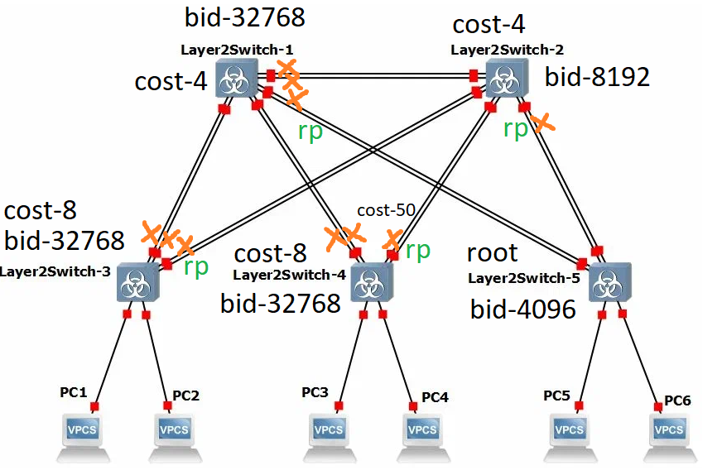

Цена маршрутов таже что и была, за исключением значений для switch-4  
Изменился маршрут до root, но цена осталась прежней.

VLAN0001

Spanning tree enabled protocol ieee

Root ID Priority 4097

Address 0c8f.16e7.0000

Cost 8

Port 4 (GigabitEthernet0/3)

Hello Time 2 sec Max Age 20 sec Forward Delay 15 sec

Bridge ID Priority 32769 (priority 32768 sys-id-ext 1)

Address 0c19.6dad.0000

Hello Time 2 sec Max Age 20 sec Forward Delay 15 sec

Aging Time 15 sec

Interface Role Sts Cost Prio.Nbr Type

------------------- ---- --- --------- -------- --------------------------------

Gi0/0 Altn BLK 4 128.1 Shr

Gi0/1 Altn BLK 4 128.2 Shr

Gi0/2 Altn BLK 50 128.3 Shr

Gi0/3 Root LIS 4 128.4 Shr

Gi1/0 Desg FWD 4 128.5 Shr

Gi1/1 Desg FWD 4 128.6 Shr